Vector Differential Calculus

Scalar Fields and Vector Fields

Scalar Functions
T = T( t, position ), independent of choice of coordinates

Vector Functions
v = v( t, position )
v = v₁ i + v₂ j + v₃ k
where the components of v depend on coordinate systems

[Example] Velocity Field of a Rotating Body
Angular velocity = ω
where p is the position vector ( a vector from origin to the point p )
ω = ω k,
( position vector )
v = = ω ( − y i + x j )

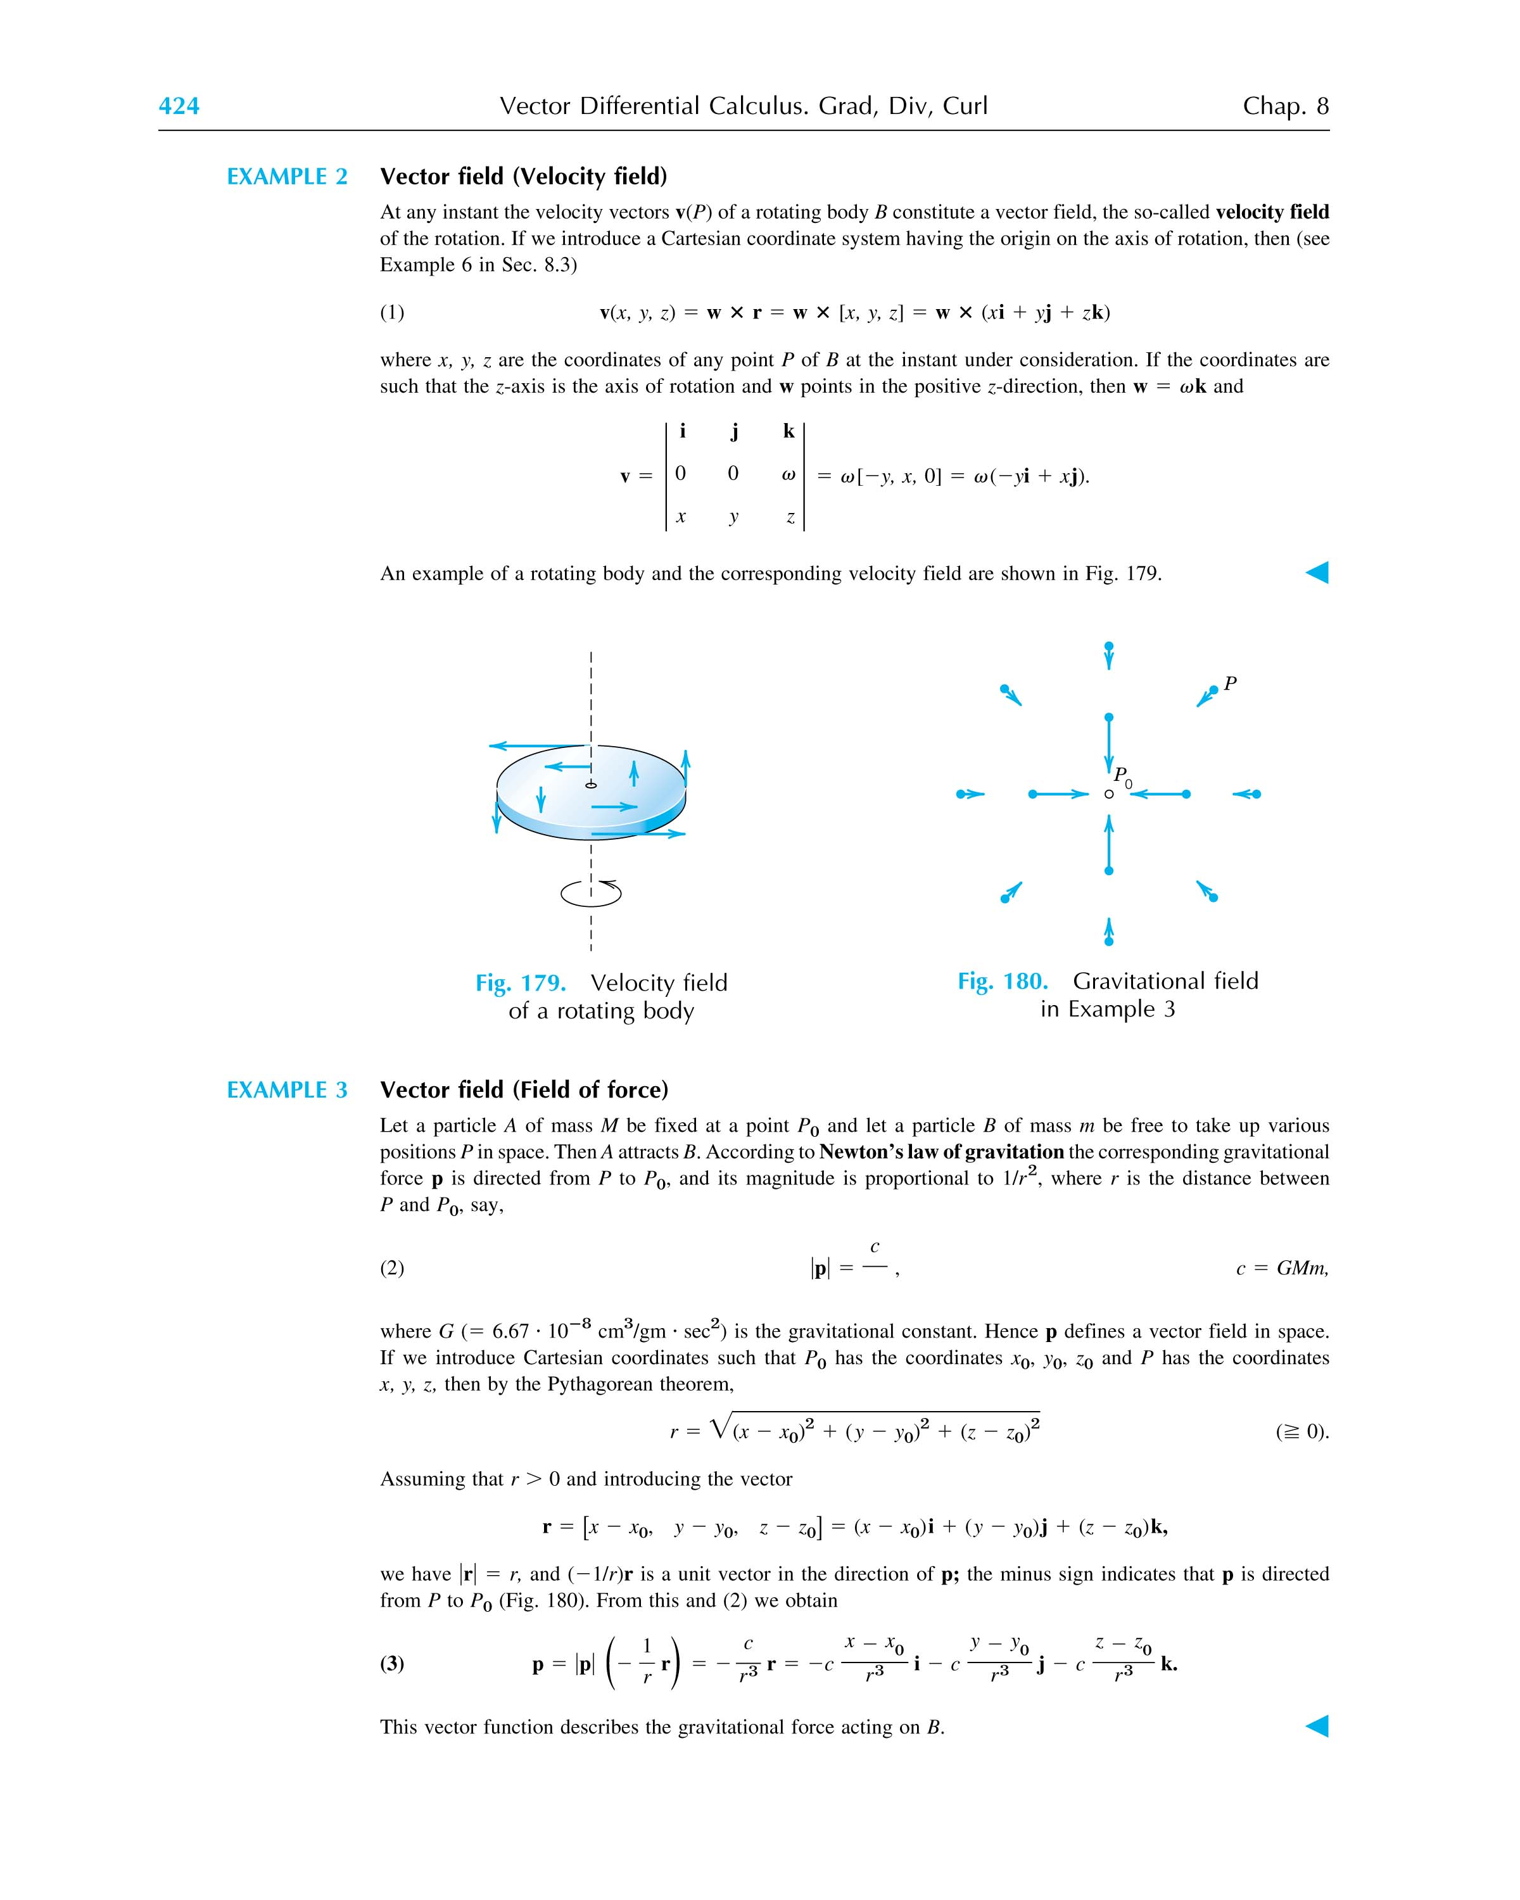
2 Derivatives of a Vector Function
(1) Vector Functions of One Variable
t : scalar (time) ⇒ v(t) : vector function
v(t) = v₁(t) i + v₂(t) j + v₃(t) k
If v(t) is continuous, ⇔ v₁(t), v₂(t) and v₃(t) are continuous.
Δv ∫ v(t+Δt) - v(t) = Δv₁(t) i + Δv₂(t) j + Δv₃(t) k
v'(t) ≡ = lim
= i + j + k
= Derivative of v(t) wrt t
Properties
(v + u) = +
(αv) = v + α ( α : scalar )
(u•v) = • v + u •
(u×v) = × v + u ×
( u v w )' = ( u' v w ) + ( u v' w ) + ( u v w' )
[Exercise] Show that the derivative of a vector of constant length, but changing direction, is perpendicular to the vector, i.e.,
|a| = constant and |a|≠ 0,
then
⊥ a

2) Vector Functions of Multiple Variables
v = v(t, position)
or v = v(t₁, t₂, . . . )
= v₁(t₁, t₂, . . . ) i + v₂(t₁, t₂, . . . ) j + v₃(t₁, t₂, . . . ) k
Partial derivative of v wrt t_{n}, , is
= i + j + k

- Position Vector r(t)

Definition
Position Vector: The vector from the origin O to the point P(x,y,z), corresponding to a specified value of t (parameter).
r = x(t) i + y(t) j + z(t) k
A curve in space can be represented by a position vector.
This is called parametric representation of the curve and t is the parameter of representation.
[Example] r = cos t i + sin t j
|r| = = 1
x = cos t y = sin t
x² + y² = 1 ⇒ a unit circle
[Example] r_{a}(t) = t i + t² j
x = t y = t²
⇒ x² = y
r_{b}(t) = - 2t i + 4 t² j
⇒ x² = y
r_{c}(t) = t² i + t⁴ j
⇒ x² = y
Are r_{a}, r_{b} and r_{c} the same curve?
Notice that this representation gives an orientation of the curve C, i.e., the direction and speed of traveling along C as t increases.

Two other kinds of representations suitable for space curves:
- y=f(x) (projection of C into xy-plane) and z=g(x) (projection of C into xz-plane)
- F(x,y,z)=0 and G(x,y,z)=0 (intersection of two surfaces)

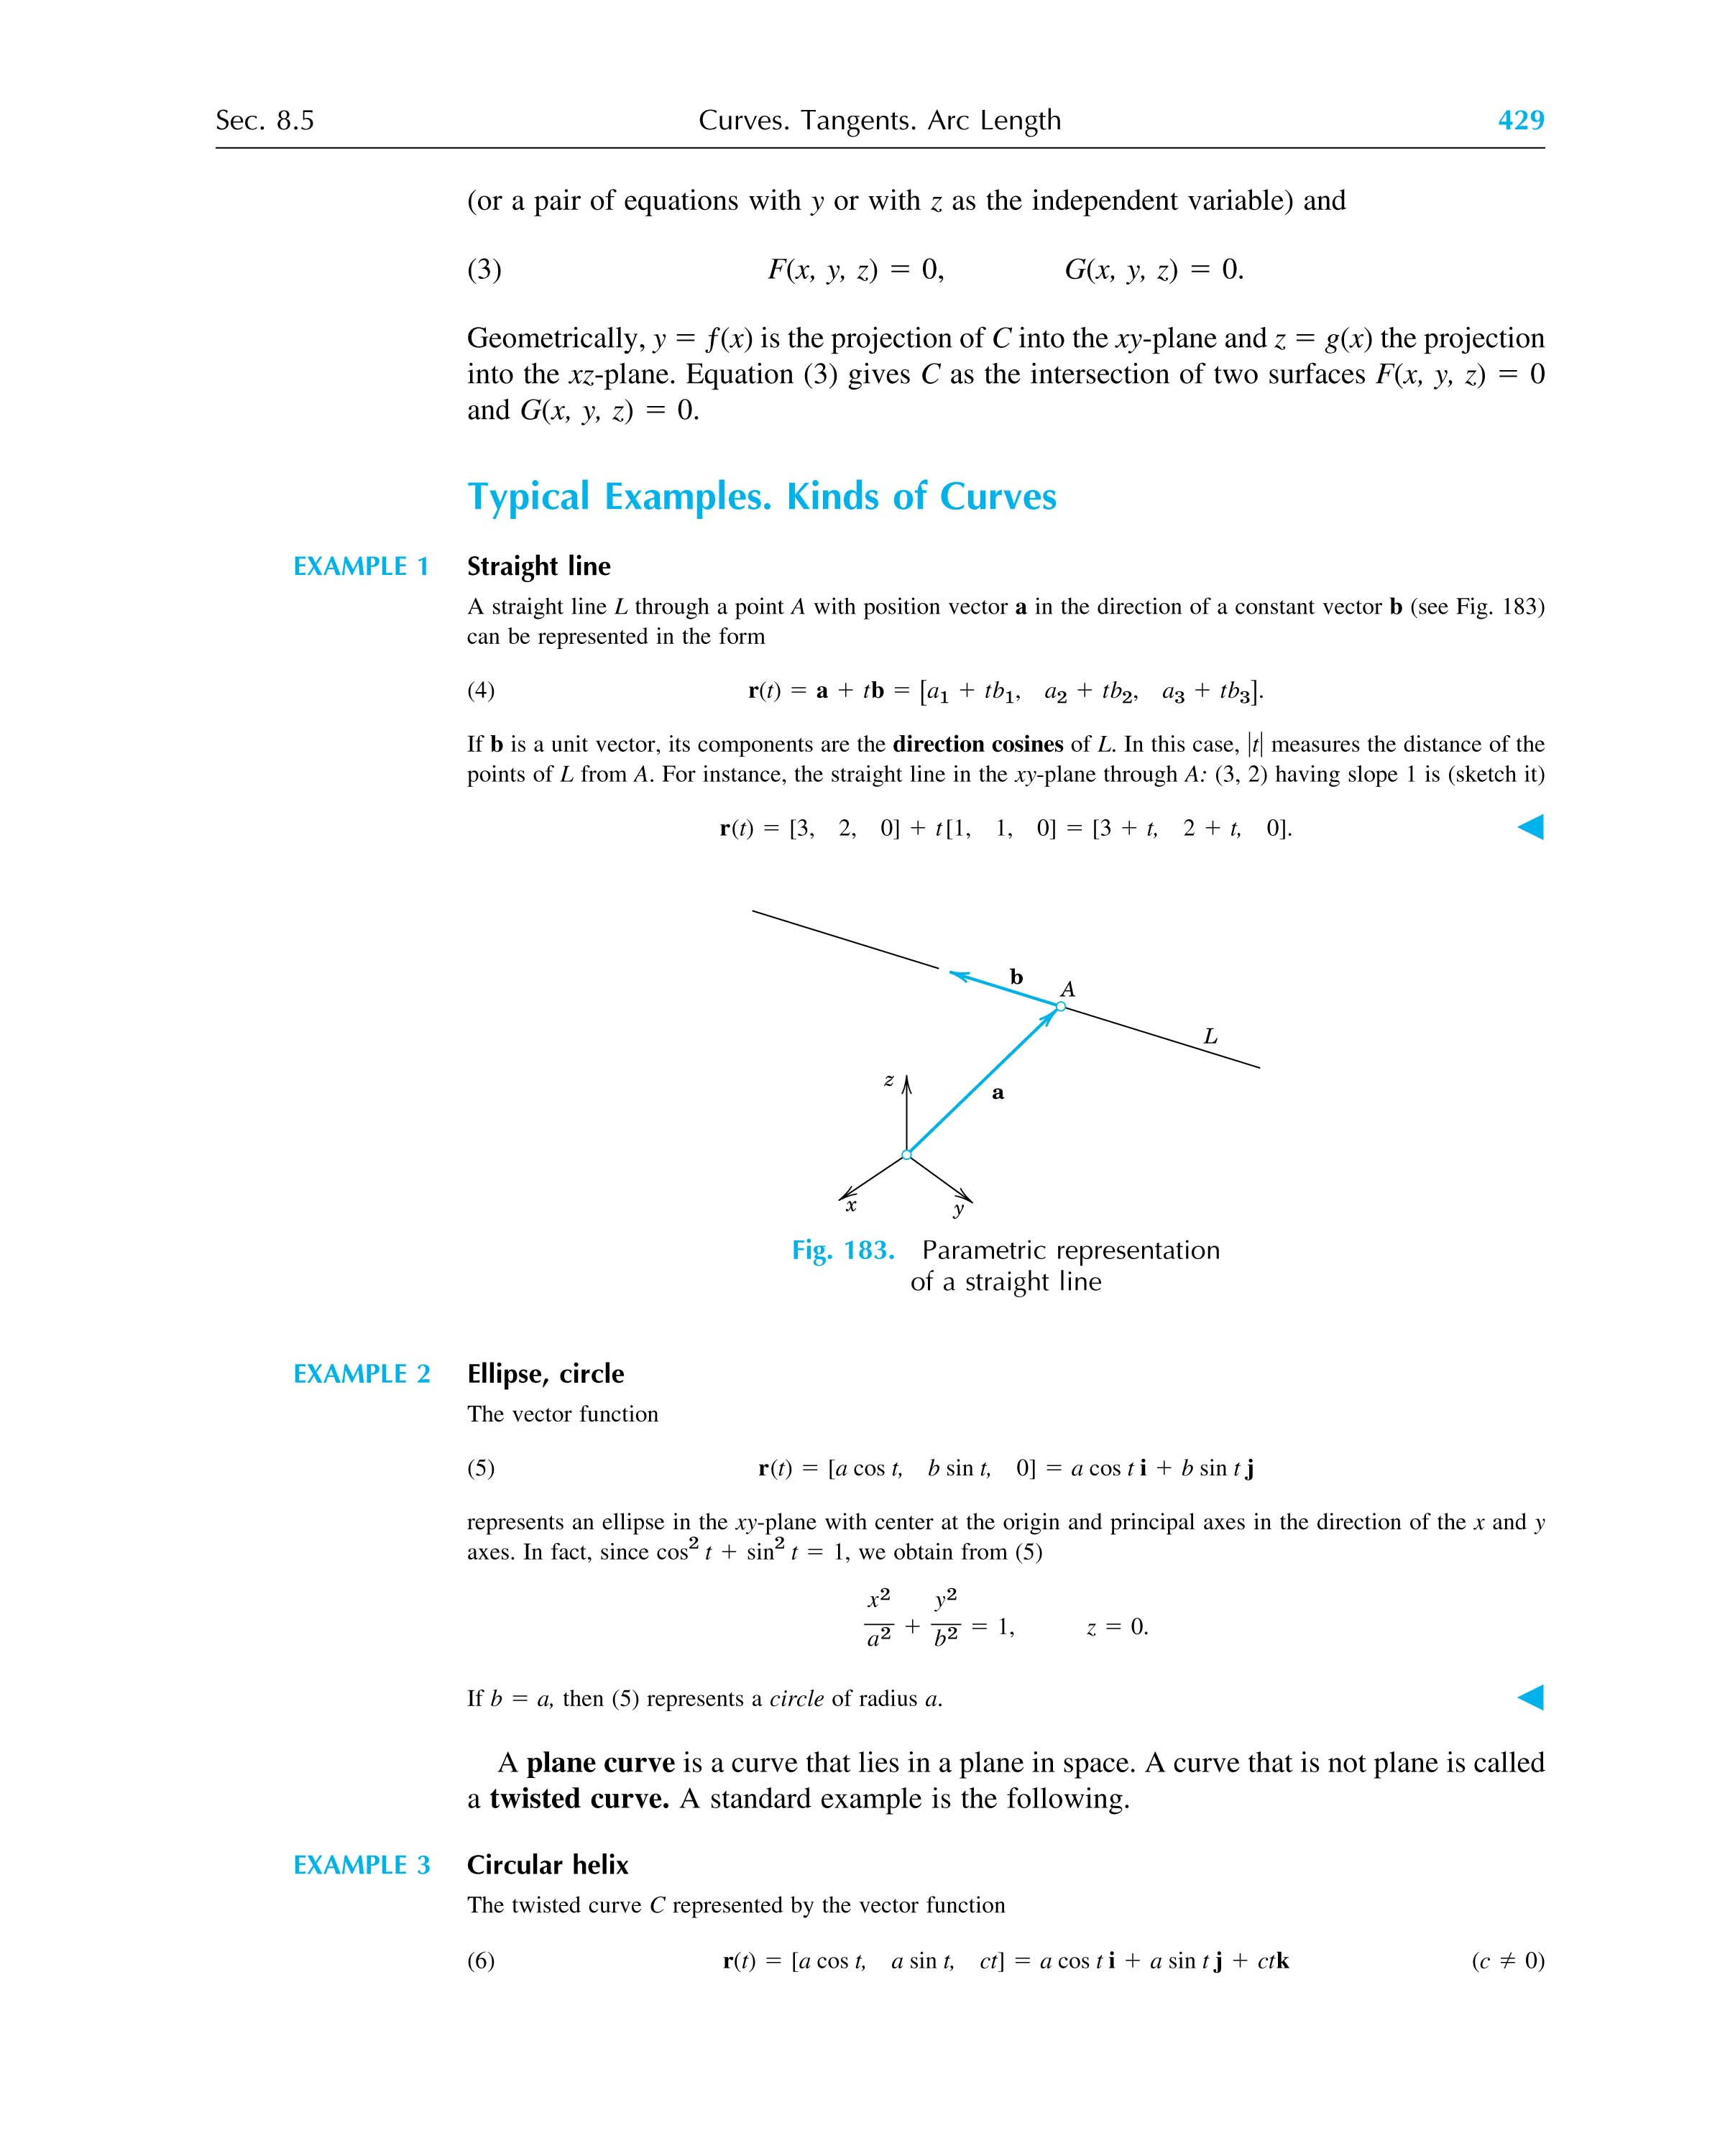

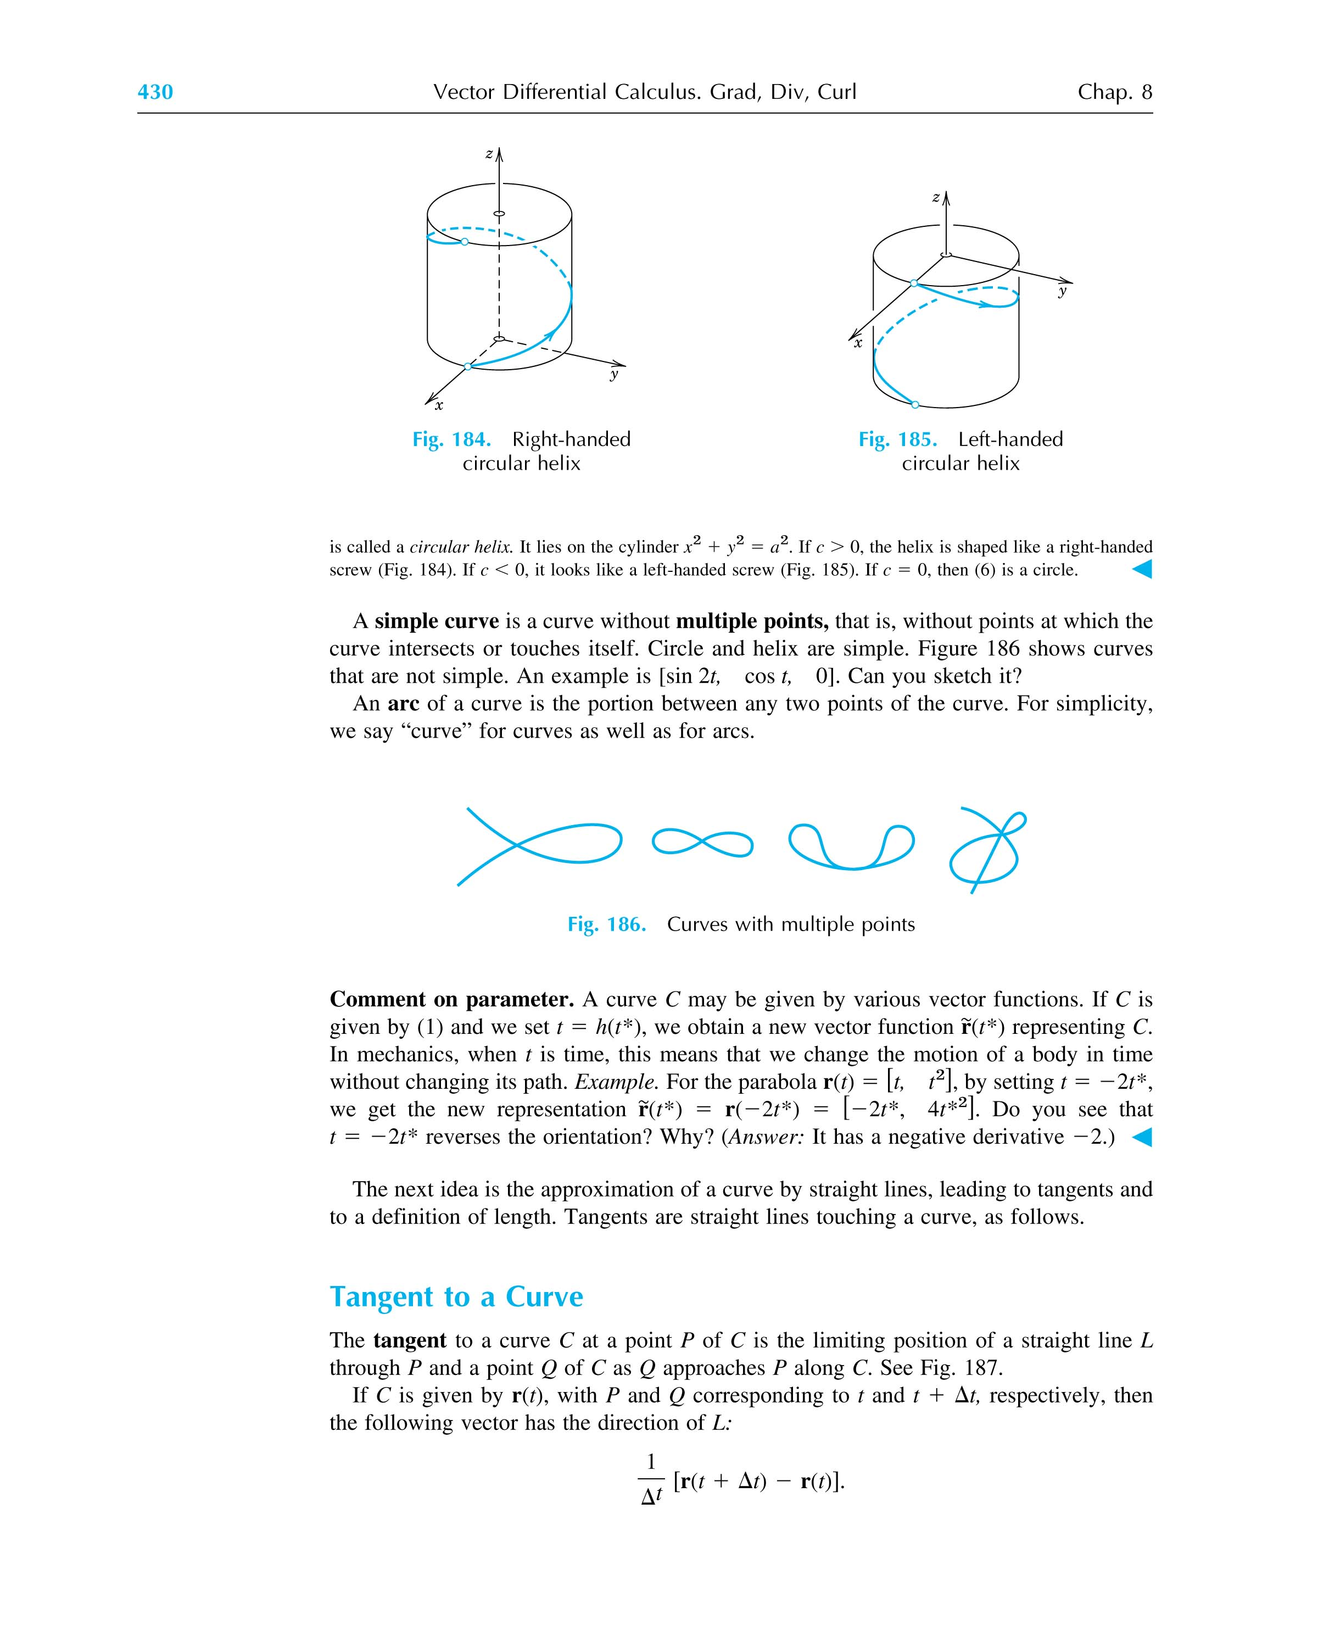

Derivative of a Position Vector
r(t) = x(t) i + y(t) j + z(t) k (represents a space curve!)
r'(t) = = i + j + k
Physical Meaning of r'(t)
By definition of derivative
r'(t) = lim= lim
∴ r'(t) is tangent to the curve at the point P ( Note that r'(t)•r(t) is not necessarily 0, i.e., not perpendicular ). Note .
r'(t) : Tangent Vector of C at P
: Unit Tangent Vector of C at P = u(t)
then r + ω r'(t) : Position Vector of a Point on the Tangent Line

Length of a Curve
∴ Length of a Curve = dt
where (from t = a to b)
Arc Length Function s(t) =

The choice of is arbitrary; changing means changing s by a constant. Differentiate s(t) w.r.t. t and then square it, we obtain

Relationship between t and s
Note that the length of dr (a vector) is ds (a scalar), i.e.,
ds = |dr|
or ( ds )² = dr • dr
In addition, dr = dx i + dy j + dz k
we have dr • dr = ( dx )² + ( dy )² + ( dz )²
∴ (ds)² = (dx)² + (dy)² + (dz)²
Thus, the arc length function s can be related to the parameter t as
ds =
= dt
ds = dt
Note that the unit tangent vector at P on the curve r(t) is given by
u = =
= i + j + k =
Hence, the derivative of r with respective to s ( the arc length function ) is the unit tangent vector.
[Exercise] Show that u ⊥

[Example] Calculate the length of the arc of the curve
r(t) = ( 2t - t² ) i + t^{3/2} j
between t = 1 to t = 3.
[Solution] r'(t) = ( 2 - 2 t ) i + 4 j
|r'(t)|
l = = 12
[Exercise] r(t) = cos t i + sin t j + t k
Calculate
(1) the unit tangent vector u(t) at t = π/3 and
(2) the length of the arc from t = 0 to t = 4.
[Solution] u(π/3) = − i + j + k
l = 4

[Example] Express r in terms of arc length function s if
r(t) = ( 2t - t² ) i + t^{3/2} j
[Solution] Take t = 0, (x,y) = (0,0) as initial point, then
= |r'(t)| = 2 ( t + 1 )
∴ s = = t² + 2 t
⇒ t² + 2 t - s = 0
and t = - 1 ( take t > 0 )
thus x(t) = 2 t - t² = 4 - 4 – s = x(s)
y(t) = t^{3/2} = =y(s)
∴ r(s) = ( 4 - 4 - s ) i
+ j

4 Particle Path, Velocity and Acceleration

Particle Path
Particle moves with its position vector r(t)
C : particle path

Velocity
v = = r' where t: time
|v| = = = = arc length/unit time = speed
Note that v = u = u ( = = speed )
where u is a unit tangent vector.

Acceleration
a ≡ =
Since v = u = u
a = u +
= u + ( since = )
= u + ()
∴ a contains
Alternatively, the tangential acceleration a_{tang} can be obtained by calculating the component of a in the tangent direction ( i.e., u, where u = v/|v| ) , i.e.,
a_{tang} = ( a•u ) u =
The normal acceleration a_{normal} can then be calculated by
a_{normal} = a - a_{tang}
[Example]
r(t) = cos t i + sin t j
v(t) == - sin t i + cos t j (t) = |v(t)| = 1
thus, d/dt = 0, speed = constant
a(t) == - cos t i - sin t j ≠ 0
Note that a(t) is normal to the particle path.

5 Curvature and Torsion of a Curve
Definition
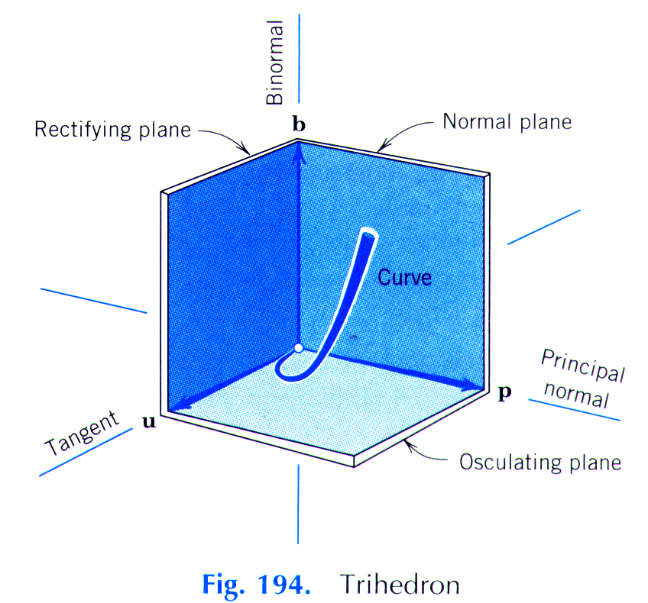
r(s) : position vector, s: arc length
u(s) ≡ : unit tangent vector, i.e.,

Since u ⊥
We define
p ≡
where
p = unit principal normal vector and
κ = = |u'(s)| = |r''(s)| = curvature
(A measure of the deviation of the space curve from its tangent!)
ρ ≡ = radius of curvature

ds = | dr |
= | r(t)' |
( The relationship between s and t can then be obtained!)
and u(s) = =
κ(s) = =
= a measure of the deviation of space curve from its tangent.
Also, we define
b ≡ u × p = unit binormal vector
[Example] Find the radius of curvature of a circle on x-y plane.
[Sol'n]
The position vector of a circle is
r = x i + yj = R cosθ i + R sinθ j
If s=0 at θ=0, ∴ s= R θ, ∴ θ =
∴ r(s) = R cos() i + R sin() j
r'(s) = = - sin() i + cos() j
r''(s) = - cos() i - sin() j
|r''(s)| = ∴ ρ(s) = = = R

[Exercise] If C is defined by r(t) = x(t) i + y(t) j with r'(t) ≠ 0, the curvature κ at the point r(t) is
=
or κ(t) =
where r' and r'' are derivatives of r wrt t.

[Exercise] r = cos t i + sin t j + t k
Find κ(s), p(s), u(s) and b(s)
[Answer]
u(s) = i + j + k
p(s) = - cos i - sin j
κ(s) =
b(s) = i + j + k

Torsion
r(s) : Curve
u(s) ≡ : unit tangent vector
p(s) ≡ : unit principal normal vector
b(s) ≡ u × p : unit binormal vector
b' ≡ = ??
Since b ⊥ u (by definition) ⇒ b•u = 0
and (b•u)' = 0 ( wrt s )
or b'•u + b•u' = 0
But u' = κ p which is ⊥ b (also by definition) ⇒ b•u' = 0
∴ b'•u = 0 or ⊥u
In addition, b'⊥b (recall that |b| = 1 so that ⊥b)
Since ⊥u and ⊥b ∴ = - τ p
where τ is the torsion which measures the rate of twisting of curve C or the deviation of curve C from the osculating plane ( |b'| = |-τ p| = |τ| ). The minus sign is conventional to make torsion positive for a right-handed helix.
Since andare linearly independent vectors, we represent any vector in space as a linear combination of these vectors.

[Exercise] r = cos t i + sin t j + t k
[Answer]
u(s) = i + j + k
p(s) = - cos i - sin j
κ(s) =
b(s) = i + j + k
(Obtained in the previous example)
>0

6 The Chain Rule and the Mean Value Theorem (for functions with more than one independent variable)

(1) Chain Rule

Continuity
Let f(x, y) be defined at every point (x, y) in a neighborhood of (x₀, y₀), then f(x, y) is continuous at (x₀, y₀) if
limf(x, y) = f(x₀, y₀)

Partial Derivatives of f
= lim
= lim

Chain Rule
(i) x = x(t), y = y(t) and f = f(x, y)
= +
(ii) x = x(u, v), y = y(u, v), and f = f(x, y)
= +
= +

(2) Mean Value Theorem
f(x, y), , and are continuous in the domain D, and that a straight line segment joining points :(x₀, y₀) and :(x₀+h, y₀+k) is in D, then
f(x₀+h, y₀+k) - f(x₀, y₀) =
where (x*, y*) lies on the line segment.
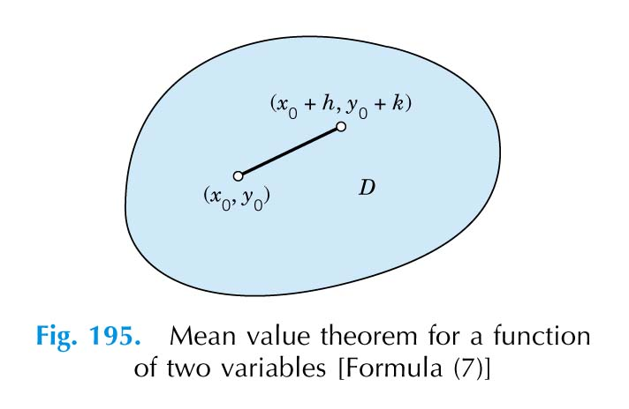
7 Gradients, Directional Derivatives

Definition of Gradient
f = f(x, y, z) --- a scalar function
The gradient of f , ∇f (del f, or grad f) is given by the vector field
∇f = i + j + k
where ∇ (nabla, del) is a differential operator.
∇ ≡ i + j + k
[Example] f = x y, ∇f = y i + x j

Properties: ∇ is a linear operator:
∇(αf) = α(∇f)
∇(f+g) = ∇f + ∇g

Directional Derivative
f = f(x, y, z) a scalar function
r = x i + y j + z k position vector
The difference of f between any two points r and r+Δr
Δf =
= Δx + Δy + Δz + . . . (Higher order terms)
= ∇f•Δr + . . .

If we let Δs = |Δr| (length of Δr), then
= + + + . . .
⇒ lim=(scalar) derivative of f in the direction of Δr
= + +
= (i + j + k )•( i + j + k )
= ∇f•

Note that in the above expression, = is the unit vector in the direction of dr.
∴ = ∇f• or df = ∇f•dr

Recall the projection of a onto b:
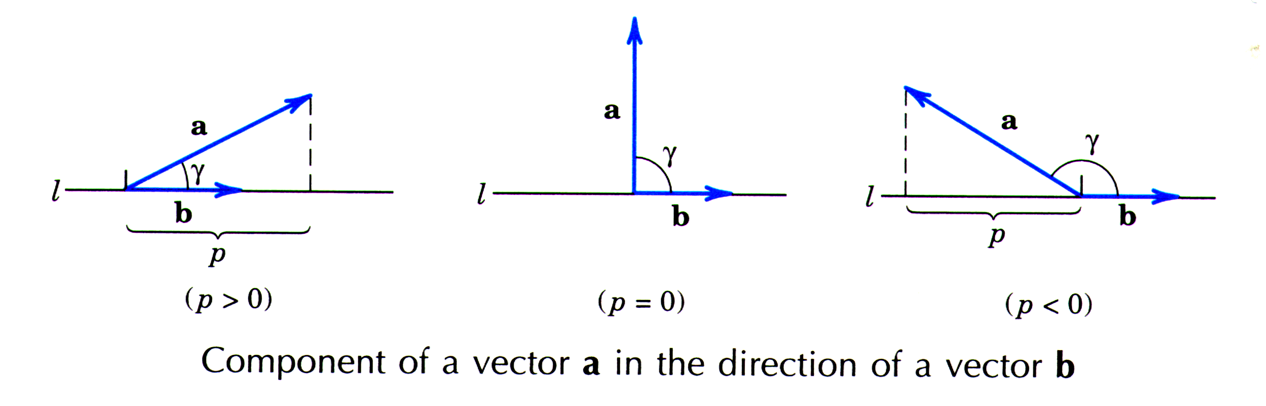
Since dr/ds is the unit vector, we have
= ∇f•= scalar projection of ∇f in the direction of
= directional derivative of f in the direction of

[Example] Let f = x y², calculate the directional derivative of f in the direction of b = 2 i + 3 j at point (4, -1).
[Solution]
A unit vector in the direction b is given by
u = i + j
Since ∇f = y² i + 2 x y j
∴ = ∇f•u = = -

[Exercise] f = x ln y - e
Find the directional derivative of f in the direction of b = i - j + 3 k

Physical Meaning of Gradient - Maximum Increases
Since dr/ds is a unit vector, |dr/ds| = 1
∴ ∇f•= = |∇f| cos γ
thus the directional derivative of f in the direction dr/ds is the component of the gradient of the f in the direction dr/ds.
Since = |∇f| cos γ
∴ has a maximum if cos γ = 1 and γ = 0.
Thus, f increases most rapidly in the direction of its gradient.

[Theorem]
Let f(P)=f(x, y, z) be a scalar function having continuous partial derivatives. Then grad f exists and its length and direction are independent of the particular choice of Cartesian coordinates in space.
If at a point P the gradient of f is not the zero vector, it has the direction of maximum increase of f at P.

Furthermore, f is stationary (i.e., df = 0) in the direction perpendicular to its gradient.
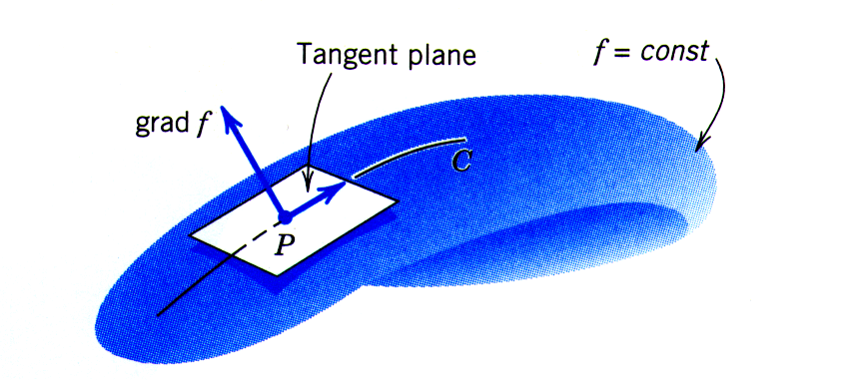
f = constant on the surface (contour)
df = 0 = dx + dy + dz = ∇f•dr
⇒ dr ⊥ ∇f where dr is on the surface f = constant.

[Theorem]
Let f be a differentiable scalar function that represents a surface S: f(x, y, z)=c=constant.
Then if the gradient of f at a point P of S is not the zero vector, it is a normal vector of S at P.

[Example] Find the normal of the curve
f(x, y) = ln(x² + y²) = constant
Since ∇f ⊥ the surface of f = constant,
∴ ∇f = i + j = i + j

[Example] Find the unit normal to the surface of
f(x, y, z) = x y³ z² = 4 at (-1, -1, 2).
Now ∇f = ( y³ z² i + 3 x y² z² j + 2 x y³ z k )
= - 4 i - 12 j + 4 k
n = = - i - j + k

[Example] From Newton’s law of gravitation, the force of attraction between two particles is:

Note that this force is the gradient of a scalar potential function of the gravitational field, i.e.
i.e.

This is because

Laplace Equation:

This is due to

It can be shown that

the force field produced by any distribution of masses is given by a vector function that is the gradient of the scalar function f and

f satisfies the Laplace equation in any region of space that is free of matter.

8 Divergence and Curl of a Vector Field

Definitions

If v = v₁ i + v₂ j + v₃ k (Notice that this is a vector function)
then ∇•v = •{ v₁ i + v₂ j + v₃ k }
= + +
= divergence of the vector v = div v

∇ × v = × { v₁ i + v₂ j + v₃ k }
=
= i + j + k
= Curl of v

If f = f(x, y, z) (a scalar function)
then ∇•(∇f) = + + = ∇²f
or ∇²f = div(grad f) = Laplacian of f

Physical Meanings

(i) Divergence:

[Example] The gravitational force is the gradient of the scalar function, which satisfies Laplace equation . Thus, .
[Example] Motion of a compressible fluid.
ρ = density [ mass/volume],
ρv = mass flux [ mass/(area)(time) ]
∇•(ρv) = rate of mass loss per unit volume [ mass/(volume)(time) ]
= - ∇•(ρv) ⇒ Equation of Continuity
(a) ρ = constant (incompressible fluids) ⇒ ∇•v = 0
(b) At steady state (i.e., ), ⇒ ∇•(ρv) = 0
(ii) Curl ⇒ rotational and irrotational flows

Some Important Identities (Exercises)

∇•φv = φ∇•v + v•∇φ
∇×φv = φ∇×v + ∇φ×v
∇•(u×v) = v•∇×u - u•∇×v
∇× (u×v) = v•∇u - u•∇v + u(∇•v) - v(∇•u)
∇(u•v) = u•∇v + v•∇u + u× (∇×v) + v× (∇×u)
∇× (∇φ) = curl grad φ = 0
∇•(∇×v) = div curl v = 0
∇× (∇×v) = curl curl v = ∇(∇•v) - ∇•(∇v)
= grad div v - ∇²v
∇•(∇φ₁×∇φ₂) = 0
Note that here v•∇u ≡ u
9 Vector Analysis in Curvilinear Coordinates
(Orthogonal Coordinate Systems)

(1) Coordinates
RCC Cylindrical Spherical
(x, y, z) (r, θ, z) (r, θ, φ)
x₁=x, x₂=y, x₃=z x₁ = r cosθ x₁ = r cosφ sinθ
x₂ = r sinθ x₂ = r sinφ sinθ
x₃ = z x₃ = r cosθ
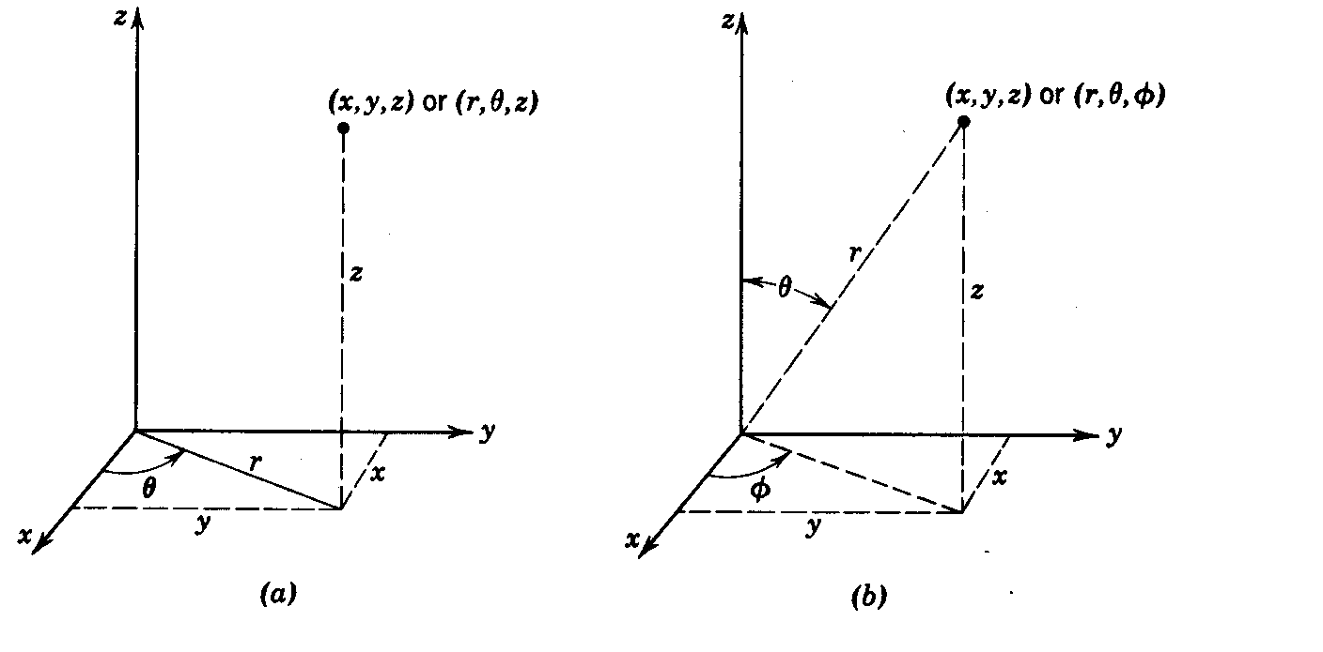

In general, x₁ = x₁(q₁, q₂, q₃)
x₂ = x₂(q₁, q₂, q₃)
x₃ = x₃(q₁, q₂, q₃)
or q₁ = q₁(x₁, x₂, x₃)
q₂ = q₂(x₁, x₂, x₃)
q₃ = q₃(x₁, x₂, x₃)

Coordinate Surfaces: q₁ = constant, or q₂ = constant, or q₃ = constant
Coordinate Line (or Coordinate Curve):
(q₁ = constant )+(q₂ = constant), only q₃ varies ⇒ coordinate line q₃
Orthogonal: coordinate curves are mutually perpendicular

(2) Position Vector and Unit Base Vectors

r = x i + y j + z k : position vector

A tangent vector e₁ to the q₁ curve at a point P is given by
e₁ =
or e₁ = =
where s₁ is the arc length along the q₁ curve. Similarly,
e₂ =; e₃ =

Since is a unit vector, we have
e₁ = h₁ δ₁
where δ₁ is the unit vector (physical base vector) tangent to the q₁ curve in the direction of increasing arc length, and
h₁ ≡ =length of e₁
Similarly,
e₁ = h₁ δ₁ ; e₂ = h₂ δ_{2 ;} e₃ = h₃ δ₃
h₁ = = = length of e₁
h₂ = = = length of e₂
h₃ = = = length of e₃
where h₁, h₂ and h₃ are scale factors.

For example, in cylindrical coordinates
(q₁, q₂, q₃) = (r, θ, z)
r = x i + y j + z k = r cosθ i + r sinθ j + z k
= q₁ cosq₂ i + q₁ sinq₂ j + q₃ k
∴ h₁ = = | cosq₂ i + sinq₂ j | = 1
h₂ = = | - q₁ sinq₂ i + q₁ cosq₂ j | = q₁ = r
h₃ = = | k | = 1

[Exercise] Show that in spherical coordinate systems
(q₁, q₂, q₃) = (r, θ, φ)
h₁ = 1 ; h₂ = r ; h₃ = r sinθ
[Hint] The position vector r in spherical coordinate system can be written as
r = r cosφ sinθ i + r sinφ sinθ j + r cosθ k

(3) Arc Length along an Arbitrary Space Curve

In RCC, (ds)² == (dx)² + (dy)² + (dz)²
In general,
dr = dq₁ + dq₂ + dq₃
= e₁ dq₁ + e₂ dq₂ + e₃ dq₃
= + +
= e₁ + e₂ + e₃
But since = 1 ⇒ • = 1
or •
= 1
In addition, for orthogonal coordinate systems,
e₁•e₂ = e₂•e₃ = e₃•e₁ = 0
∴ e₁•e₁ (dq₁)² + e₂•e₂ (dq₂)² + e₃•e₃ (dq₃)² = ds²
or ds² = h₁² dq₁² + h₂² dq₂² + h₃² dq₃²
(Note that e₁•e₁ = h₁ δ₁ • h₁ δ₁ = h₁² )

Cylindrical: (ds)² = (dr)² + r² (dθ)² + (dz)²
Spherical: (ds)² = (dr)² + r² sin²θ (dφ)² + r² (dθ)²

(4) Element of Volume and Element of Surface

In RCC system, dV =dx dy dz, but can we write dV=dr dθ dz in cylindrical systems?
No.

(i) Element of Volume, dV

The element of volume is given by
dV = ( e₁dq₁ × e₂dq₂ • e₃dq₃ )
= ( δ₁×δ₂•δ₃ ) h₁h₂h₃ dq₁dq₂dq₃
= h₁h₂h₃ dq₁dq₂dq₃

( Since δ₁×δ₂•δ₃ = 1 for orthogonal coordinate systems)

e₁ = h₁ δ₁ ; e₂ = h₂ δ_{2 ;} e₃ = h₃ δ₃
h₁ = = = length of e₁
h₂ = = = length of e₂
h₃ = = = length of e₃

Cylindrical: dV = r dr dθ dz
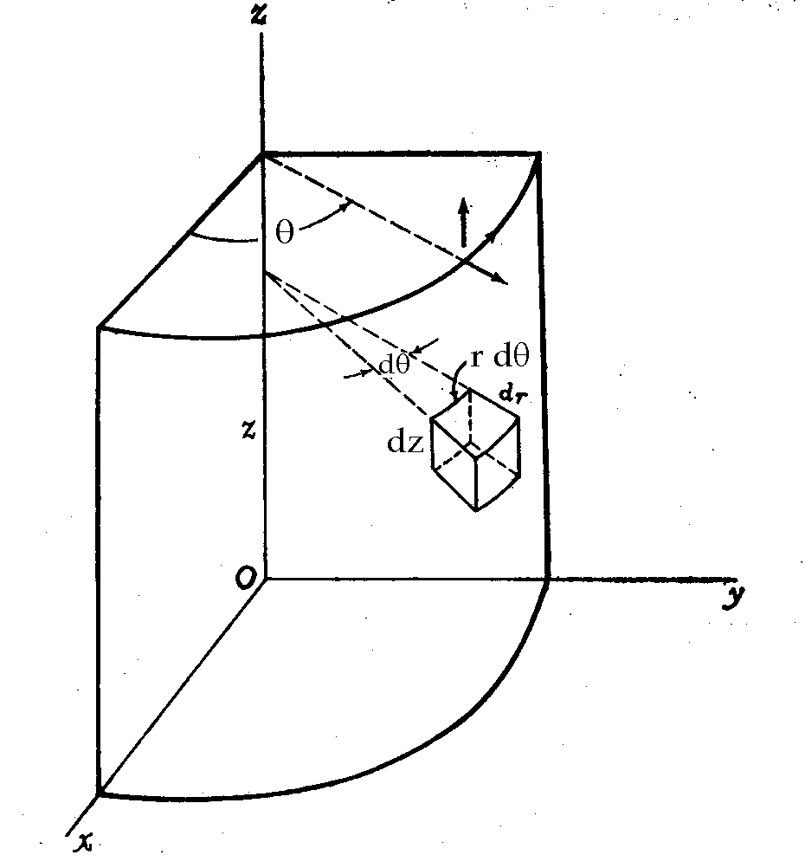

Spherical: dV = r² sinθ dr dθ dφ
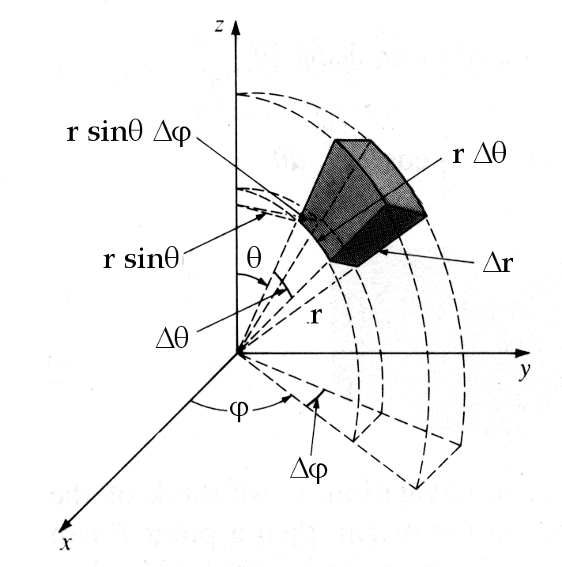

- Element of Surface, dS

On the surface q₁ = constant, the element of surface area dS₁ is given by
dS₁ = | e₂ dq₂ × e₃ dq₃ |
= | h₂ δ₂ dq₂ × h₃ δ₃ dq₃ |
= h₂ h₃ dq₂ dq₃
Similarly,
dS₂ = h₃ h₁ dq₃ dq₁
dS₃ = h₁ h₂ dq₁ dq₂
Cylindrical Coordinate:
dS_{r} = r dθ dz
dS_{θ} = dr dz
dS_{z} = r dr dθ
Spherical Coordinate:
dS_{r} = r² sinθ dθ dφ
dS_{φ} = r dr dθ
dS_{θ} = r sinθ dr dφ

(5) Gradients
df = ∇f•dr (This relation should be valid in any coordinate system!)
df = dq₁ + dq₂ + dq₃
and dr = e₁ dq₁ + e₂ dq₂ +e₃ dq₃
= h₁ δ₁ dq₁ + h₂ δ₂ dq₂ + h₃ δ₃ dq₃
If we now write
∇f = λ₁ δ₁ + λ₂ δ₂ + λ₃ δ₃
We need to determine the functions λ₁, λ₂ and λ₃ such that
df = ∇f•dr
∴ dq₁ + dq₂ + dq₃
= h₁ λ₁ dq₁ + h₂ λ₂ dq₂ + h₃ λ₃ dq₃
Since dq₁, dq₂ and dq₃ are linearly independent, we have
λ₁ = ; λ₂ = ; λ₃ =
⇒ ∇f = + +
∴ ∇ = + +
= δ₁ + δ₂ + δ₃
For example, in cylindrical coordinates
∇f = δ_{r} + δ_{θ} + δ_{z}
or ∇ = δ_{r} + δ_{θ} + δ_{z}
[Exercise] What is ∇f in spherical coordinates?
∇ = δ_{r} + δ_{θ} + δ_{φ}
(6) Divergence ∇•v

v = v₁ δ₁ + v₂ δ₂ + v₃ δ₃
∇•v = ∇•(v₁ δ₁ + v₂ δ₂ + v₃ δ₃) = =?

∇•v₁δ₁ = ∇•(h₂h₃v₁ ) (since ∇•φv = φ∇•v + v•∇φ)
= ∇(h₂h₃v₁) •+ h₂h₃v₁ ∇•
but ∇•= ∇•( × )
= ∇•( ∇q₂ × ∇q₃ ) = 0 [Recall that ∇•(∇φ₁×∇φ₂) = 0]
∴ ∇•v₁δ₁ = •∇(h₂h₃v₁)
= •( + δ₂ . . . )
=
∴ ∇•v = •∇(h₂h₃v₁) + •∇(h₃h₁v₂) + •∇(h₁h₂v₃)
=

[Example] Cylindrical coordinate
∇•v = + +

(7) Laplacian ∇² = ∇•∇
(8) Curl ∇×v
∇×v = ∇ × (v₁δ₁) + ∇ × (v₂δ₂) + ∇ × (v₃δ₃)
But ∇ × (v₁δ₁) = ∇ × (h₁v₁) (since ∇×φv = φ∇×v + ∇φ×v)
= (h₁v₁) (∇ × ) + (∇h₁v₁) ×
However,
∇ × = ∇× (∇q₁) (since ∇q₁ = )
= 0 [since ∇× (∇φ) = 0]
thus we have
∇× (v₁δ₁) = (∇h₁v₁) × = - × ∇h₁v₁
₌
= - +
=
∴ ∇×v =
[Example] For cylindrical coordinates
∇×v =

